QUEENS PARK TENNIS CLUB, BRIGHTON
ANNUAL GENERAL MEETING

Sunday 8th January 2023, 17:00
Clubhouse, Queen’s Park Tennis Club

ATTENDANCE
BOARD | MEMBERS x36
Charlie Baines (Chairman) | Barbara Michael | Leonie Moore
Mel Bowden | Bego Escorihuela | Lucy Constantine
Conrad Brunner | Brenda Maguire | Lyn-Ora Knotts
Stephen Davies | Chris Rendel | Maggie Gordon-Walker
Alan Sanchez | Chris Wilson
Stephen Lee | Eddie Crowther | Matt Rickard
 | Fiona Sloan | Paul van Reyk
GUEST SPEAKER | Fiona Wilson | Pauline O’Reilly
Matt Glazier (LTA) | Garbrielle Broad | Philip Evans
 | Geralyn Meyler | Rhys Daniels
MINUTES | Jacob Chadwick | Robin Wilson
Jo Davies | Janet Enever | Sam Waller-Carr
 | Jimmy Smith | Susan Chung
 | Julian Redpath | Terry Nevin
 | Kate Buchannen | Tom Bradford
 | Katie Johnson | Trisha Rendel
 | Katie Moorman | Wendy Powell

APPROVAL OF THE CHAIRMAN
Stephen requested approval from those present for Charlie Baines to chair the meeting. All in favour. CARRIED.

APOLOGIES FOR ABSENCE
There were apologies from:
Mark Cull
Ian Teasdale
Charlie Brown
MINUTES OF THE LAST AGM
The minutes of the last AGM (07.01.21.) which had been previously circulated to the membership were agreed as a correct record of the meeting without amendment.

MATTERS ARISING (Not covered elsewhere on the Agenda)
There were none.

LTA REPORT (Matt Glazier)

Matt presented an outline of the role of the LTA in supporting recreational tennis and tennis clubs such as QPTC. He had personally been involved in both Brighton and with QPTC for last four years.

The LTA had set aside £30 million from government to invest in parks facilities, to bring back to life tennis courts in these settings.

Not just from a facility system, but booking system, gate systems etc.

Aiming for a consistent way for how people can find out about courts and create a vibrant and exciting tennis landscape. Consistent court surfaces etc.

The aim is to achieve a consistent quality of offer for everyone that wants to book a court across Brighton.

Question from the floor – Are councils giving up courts across the UK?

Matt Glazier – Some areas have capacity to manage in-house, but other authorities like B&H outsource to clubs like QPTC CIC. In Surrey for example they manage themselves.

Question from the floor – Is there a coaching update? An important part of LTA’s job.

Matt Glazier – We don’t need to see a coaching programme for every club. Blakers Park don’t have one. But yes, it is important and helps to get players playing regularly. We do help get coaching up and Mel and Jimmy are a great example of what good looks like and Jimmy’s award is testament to that.

Question from the floor – Ensuring coaching levels are a consistent standard is important part of the LTA?

Matt Glazier – Yes, where this is a CIC or local organisation they must have rules and regulations in place to ensure their coaching have the right standards maintained so coaching offer is consistent.

DIRECTORS’ REPORTS

MEMBERSHIP REPORT (Alan Sanchez)

Alan presented a comparative analysis of the membership figures across each of the different categories of membership for 2021 and 2022. They are:

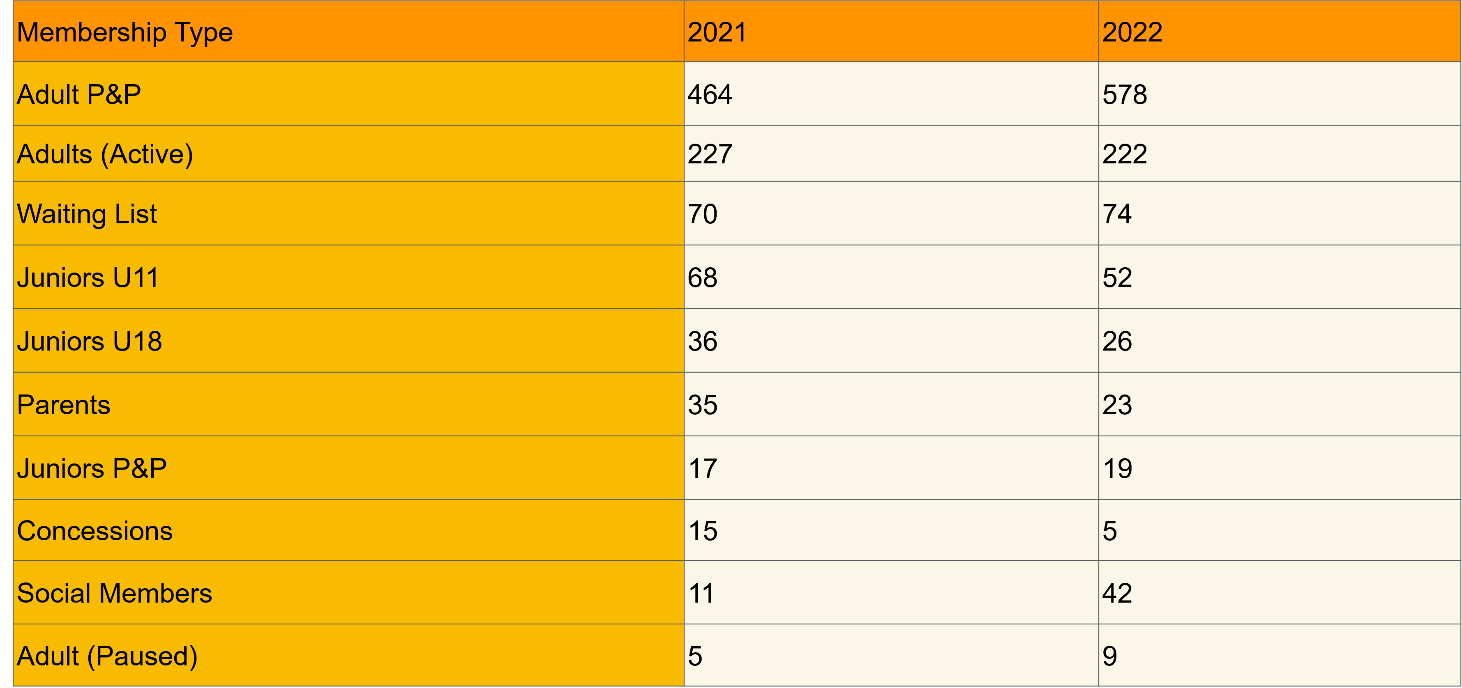

Alan also presented an example analysis of court usage by booking.

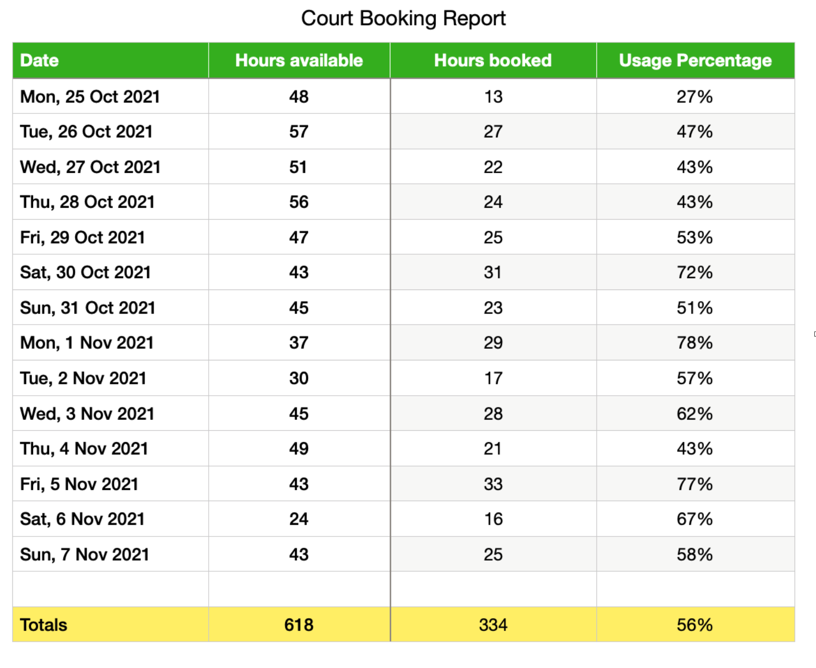
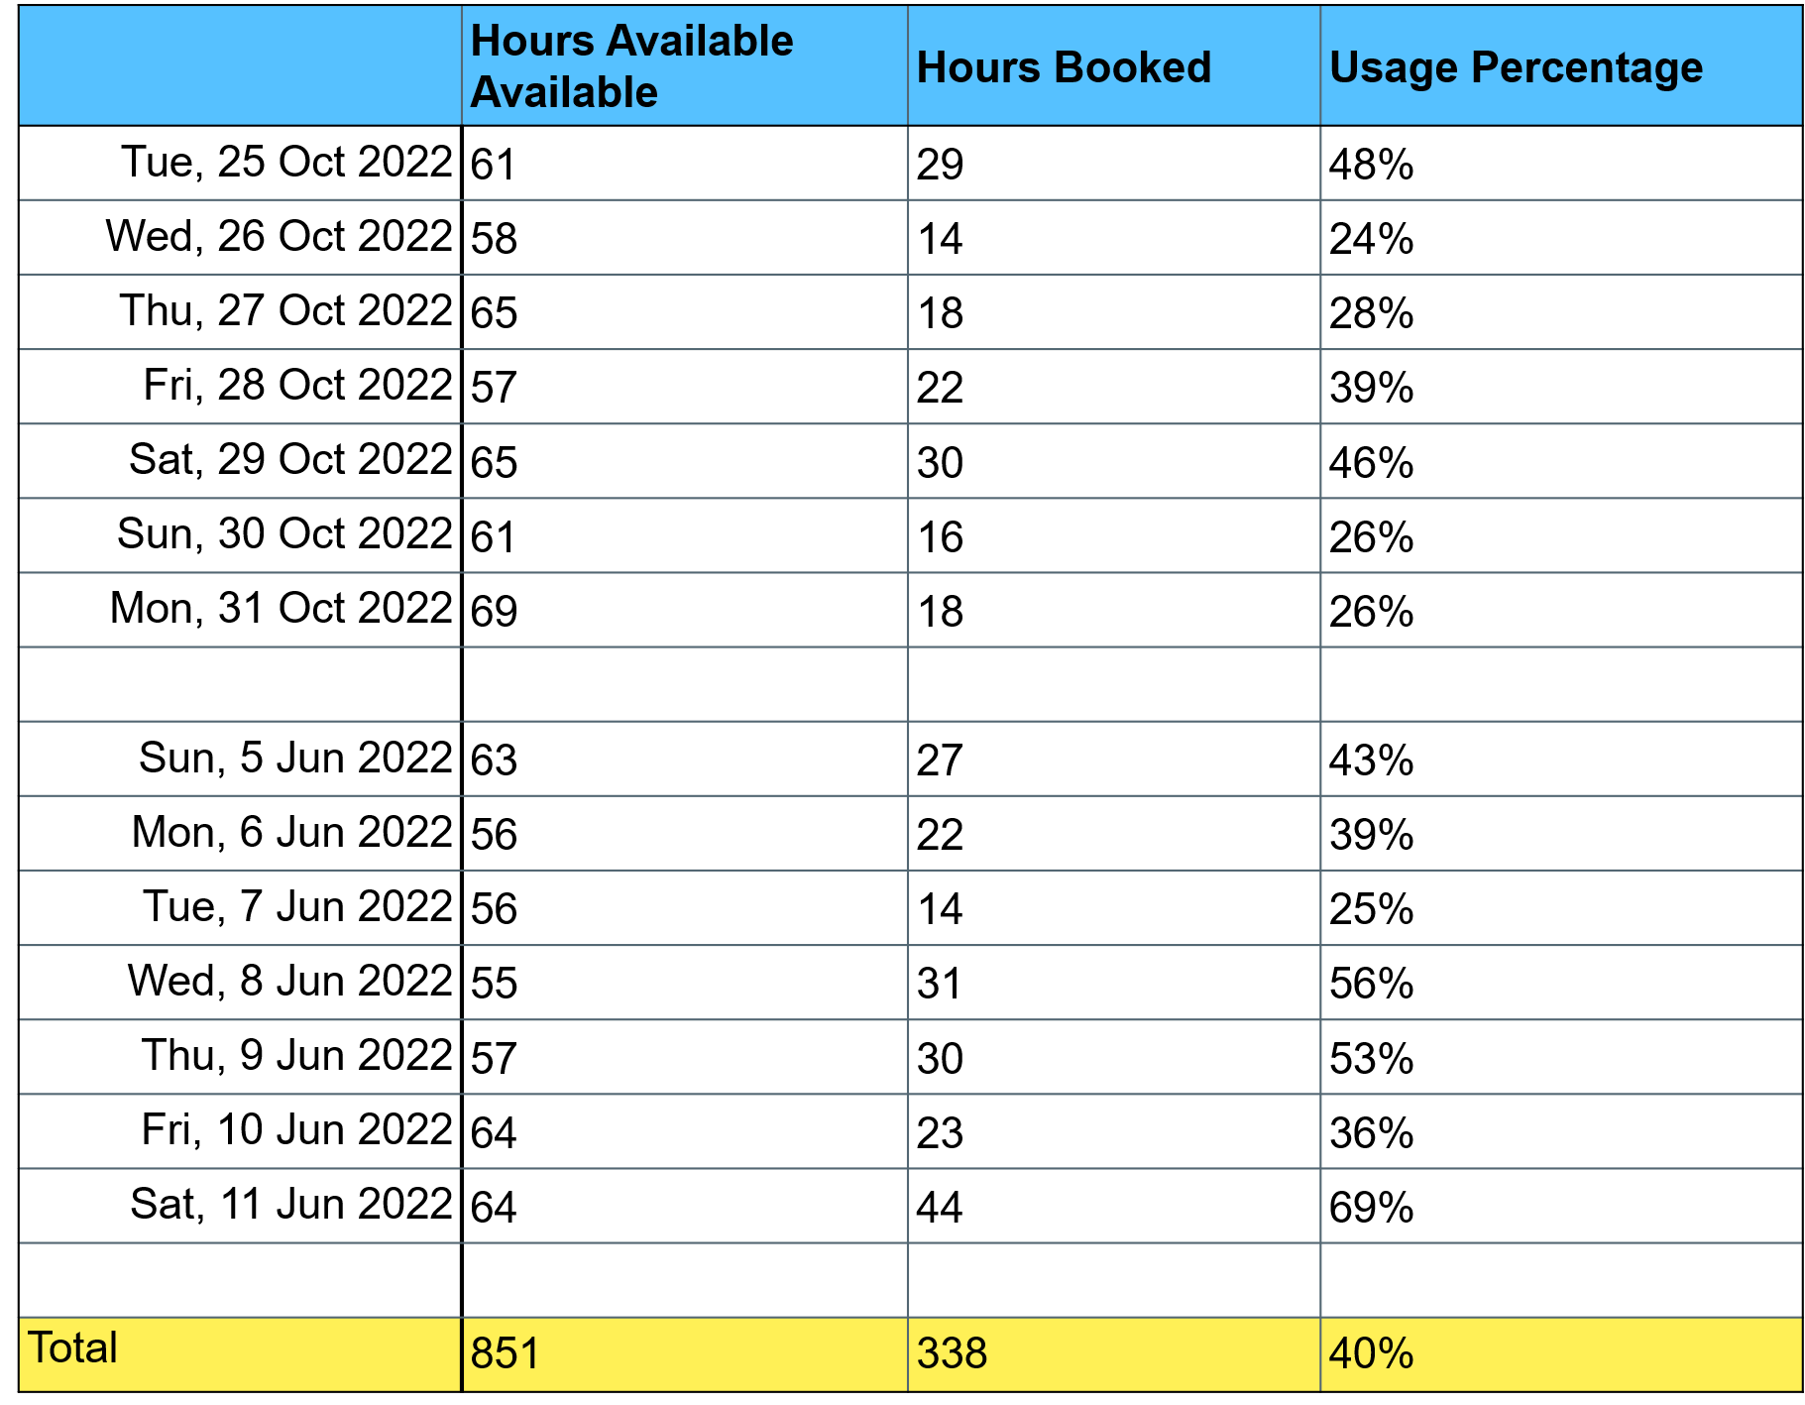
The sample results indicate that access to courts remains achievable in most circumstances.

Question from the floor – Are we happy with the current level of membership and the maintenance of the waiting list at its current level?
Alan Sanchez - Yes, we are happy with current numbers.

Question from the floor – Pay and Play?
Alan Sanchez – Yes 578 bookings is great and brings in a lot of revenue.

Comment from Alan Sanchez – Re court booking, on average 60% of the time courts are available

Question from the floor – Re the people booking, charts don’t always tell the full story. If it showed per hour throughout the day it would be more accurate.

Conrad Brunner – we’d need to do times of the day and produce another chart.

Alan Sanchez – you can book 7 days in advance and there are 6 courts available.
Comment from Barbara Michael – 2 courts only on Sat as the rest are used for coaching so can’t book.

Alan Sanchez – Yes times when to book courts can be hard, but maybe we need to see the breakdown throughout the day

[Footnote for Clarification: three courts are available for booking until 11.00am. Between 11.00 and 12.30 there are two courts available, thereafter, tournaments apart, there are six courts available.]
Question from the floor - Does it take in consideration cancellations? So number is showing number booked. Answer: yes.

Question from the floor – For Sat and Sun the chart should be altered? Can floodlights be used in the morning

Mel Bowden – From 8am floodlights can be used although the curfew switches are set for floodlights to be accessible 4.00pm till 9.00pm.

Question from the floor – I can’t book for a Sunday. Greyed out. Can’t book all year.
Alan Sanchez – It’s an app issue to do with logging in. I can help you.

Comment from the floor – People turn up on Saturday morning to attend Mel’s session, they choose to be there and have an equal right to be there as much as members.

Comment from the floor – Suggestion to have x1 coach in the morning and then x1 coach in the afternoon so splits the time some of the courts are in use.

TENNIS COMMITTEE REPORT (Charlie Brown)

Sadly, due to the unexpected absence of the Chair of the Tennis Committee it was not possible to receive a detailed report from the Tennis Committee.

COACHING REPORT (Mel Bowden)

At present there are four drop-ins a week which are all available to both members and non-members. These sessions run throughout the year. Additionally, two six-week beginner courses, in term time, are available in the evenings and run by Jimmy.

During the Summer over any one week approximately 100 adults are coached by both Jimmy and myself in group and individual lessons.

Interesting point over the 100 adults who are coached;
- 59 are members
- 27 are on the waiting list
- 14 visitors

Regarding the coaching of non-members its worth pointing out that any person whether member or not has access to the drop ins, coaching courses and individual lessons. It is part of being a Community Interest Company.

As a result of a couple of emails and comments regarding the coaching hours on court we have made some changes. When Mags left we did not replace any of the Junior groups on Sunday mornings, unfortunately we also lost the she rallies initiative. This of course has a financial impact on the Club approximately £3000 a year.

I would like to start a drop-in open to everyone but in particular those 70 plus players on the waiting list. Originally scheduled for Sunday this has been shelved because of the comments regarding court availability. One thing we hope to launch is the wheelchair session and Jimmy is working on that.

COACHING REPORT (Jimmy Smith)

Jimmy provided the meeting with a verbal report of the various coaching initiatives that had been successfully developed through the course of the year for young people.

Question from the floor - Where are all the girls?

Jimmy Smith – It is a good point and one which we are continuing to seek to address. We do have a tournament for girls coming up.

Comment from the floor - My granddaughters came along, but as there were so few other girls, they gave up!

Jimmy Smith – It’s a shame Mags has moved to Australia because she was able to bring some energy to this issue. Mags was running She rallie. Emma Raducanu and Amazon Prime, with the LTA have launched a girls-only scheme aimed at getting young women into the sport. We also need more women helping deliver the coaching.

Stephen Lee – The work we do with young people with learning disabilities does include girls, but it a lot for the team to run. We want to be considered as a club that is very accessible. We should be proud of the quality of the work that the coaches have achieved in the past year and thanks to Jimmy and Mel.

Jimmy Smith – we hope to explore wheelchair sessions at the club now we have the ramp.

ESTATES REPORT (Mel Bowden)
2022 started well as, after four and a half years we finally signed the lease.
You may remember it took a total of eight solicitors (five on the Council side and three on ours) to complete.
Just to remind you the negotiations were complicated by the fact there are four Council departments who have to agree with us and each other. Not easy.
We now have a lease until 2046.
We negotiated a condition of handover clause within the lease and as result of a feasibility report the Council agreed to spend £47k on repairing the outside of the Clubhouse as part of the handover.
They ended up spending over £60k on repairs and renewals
I would like to point out one Council department, Premises and Estates has gone over and above to help us achieve this section.
The back of the clubhouse doesn’t seem significant but that area alone accounted for 60% of the total spend. All the drains were renewed, asbestos removed and new external walls installed. But the one thing it stopped was visitors to the Clubhouse.
We also had a lot of mice, which we humanly caught and released into the Quiet Garden.
With the Lease signed that triggered the completion of our LTA loan which allowed us to complete the floodlighting and build the new plantroom which houses all the control equipment for the lights.
My thanks to Matthew for his patience in helping us navigate the extremely complex application procedure.
The loan has allowed us to light all four courts.
I should add we successfully overcame two serious legal challenges to the floodlights which initially closed us down last winter.
You will all be aware the damage the sycamore tree has caused on Court 1 and now Court 2. We and the LTA continue to pursue the department head and director of the Council to allow us to remove the overhanging branches. They have to date refused to address the situation initially citing funding We offered to use our own tree surgeon or pay them to complete the job, that too was turned down. They now tell us it would harm the vista of the area. We did point out they pruned and pollarded over 30 trees in the park in 2022.
Courts 1 and 2 are 4 years old and would normally be resurfaced after 10/12 years.
Such is the damage the tree has caused we will have to resurface once the tree is cut back and an agreement to maintain pruning.
To resurface the two courts is in the order of £28,000. however these are third generation which means the courts underneath will have to be excavated to a depth of between 50mm and 75mm. To remove and take away from site something in the order of 780 sq meters of tarmac is expensive which we are advised will take the overall cost to just under £42,000.
Mathew and South Area LTA director will make a further attempt later this month to come to an agreement with the Council regarding this situation
During the break between Christmas and New Year these courts were power washed to at least make them playable. I was shocked how much mud and moss was removed from the courts. That cleaning cost the Club just under a £1,000.
The courts now have an excellent playing surface however cosmetically they will not look good.
As an interim measure we will instruct Sovereign Sports to lightly re-paint the courts as soon as the weather permits. This will affect drainage so they will drill drainage holes on the non-playing areas under the trees prior to painting.
We hope the work will take place late March / April
Of course, long term we have to reach an agreement with the Council regarding all overhanging trees. You can put lipstick on a pig but it’s still a pig!

Comment from Wendy – court 6 is cracking where cherry tree roots are coming up.
Mel Bowden – We have to deal with four departments in the council. Park and Gardens have held us back. They have refused for us to cut a tree. They are very precious regarding trees. The arborist said to Conrad re our sycamore issue on court 1 that ‘we are exaggerating the problem’.
Stephen Lee – to impress on all members, we are not going to give up on the sycamore issue; we are waiting to see the outcome of LTA negotiation. When we get the conclusion it’s our intension to bring a stronger campaign with local councillors. The courts are becoming dangerous – especially with older players and those with disabilities.
Question from the floor - Could we get an independent assessment? To take back to the council.
Mel Bowden – Sovereign Sports have literally just delivered exactly that to us this week.
Stephen Lee - Yes and LTA legal advice is available to us and will try to keep members updated through the website. We have been very gentlemanly up until this point and now we have to safe guard the physical wellbeing for members and guests when on our premises. So we cannot let the current situation remain or worsen further going forward.
Question from Barbara – does it affect our insurance?
Stephen Lee – it’s our responsibility. We have standard LTA insurance.

QPTC MEDIA REPORT (Conrad Brunner)

Queens Park Tennis Club continues to maintain a strong online presence. We don’t spend money online to promote our activities, unlike several tennis clubs in the area, but we maintain strong organic search results because we post, update and share on a regular basis. We particularly aim at sharing positive images which convey our values and passion for tennis.
More than half of all searches for our club are done via mobile phone. We spent approximately £1,300 optimising the website for online and mobile in 2021, so there were no further costs for 2022.
Fresh updates are important. We have posted dozens of stories and updates, which is why we continue to score so highly on Google search.
Events like LTA tournaments help us, because suddenly dozens of parents all over the south east are googling us, for information, images, directions etc
On the Goggle search "tennis Brighton", Queens Park Tennis Club scores higher than any other tennis club, private or public, in the city. Above the fold on page one is where all businesses want to be.
QPTC members can help us by going online giving Queens Park Tennis Club a positive five star review on Google. It really helps.
We continue to run a Google Business page which can generate over 100,000 references a month from online search. This online activity is transferred into real visits, phone calls and lots of hits and clicks on the website. Example. An airline stewardess in Vancouver, Canada, was booked to work on a Gatwick return flight. Before leaving she searched online for “tennis brighton”, found Queens Park Tennis Club, found the new Monday Night Tennis group, and registered online. She went to work, landed 12 noon the next day and was playing under lights at 6pm at QPTC. I think she had a good time.
As mentioned previously, Instagram is THE preferred social media for tennis players. The Queens Park Tennis account is by far the most followed tennis site in the city, up 15 per cent this year to 630 followers, which is more than double private clubs Southdown or the Weald, and three times more than Pav & Av.
We invite you, the members, to follow us online and to contribute at every opportunity. We will share. All of this helps keep the ship buoyant with bigger demand for coaching, holiday camps, pay & play, venue hire, and membership. Etc. It's good for us to promote Queens Park Tennis in particular, and the game of tennis in general.

Stephen Lee – Conrad and Alan put in a lot of their own time to maintain our presence online and I am sure that members would wish to record their thanks and appreciation for all of the voluntary work that this entails.

FINANCIAL REPORT (Alan Sanchez)

2021/22 Annual Accounts
Copies of the 2021/22 annual accounts had been made available to all members through announcement of the formal notice of this meeting and within it the link to the annual accounts 2021/22 on the QPTC website. The financial position fat the end of March 2022 was sound and the Independent Examiner who had verified these accounts was able to report that QPTC remained a going concern.

Income & Expenditure April 2022 – November 2022
Additionally, Alan presented a more detailed analysis of actual income and expenditure covering the period April 2022 through to November 2022. This showed a a gross net outturn in funds through the period in question which was due to the timing and payment for the development works undertaken to improve the clubhouse facilities and the floodlighting.
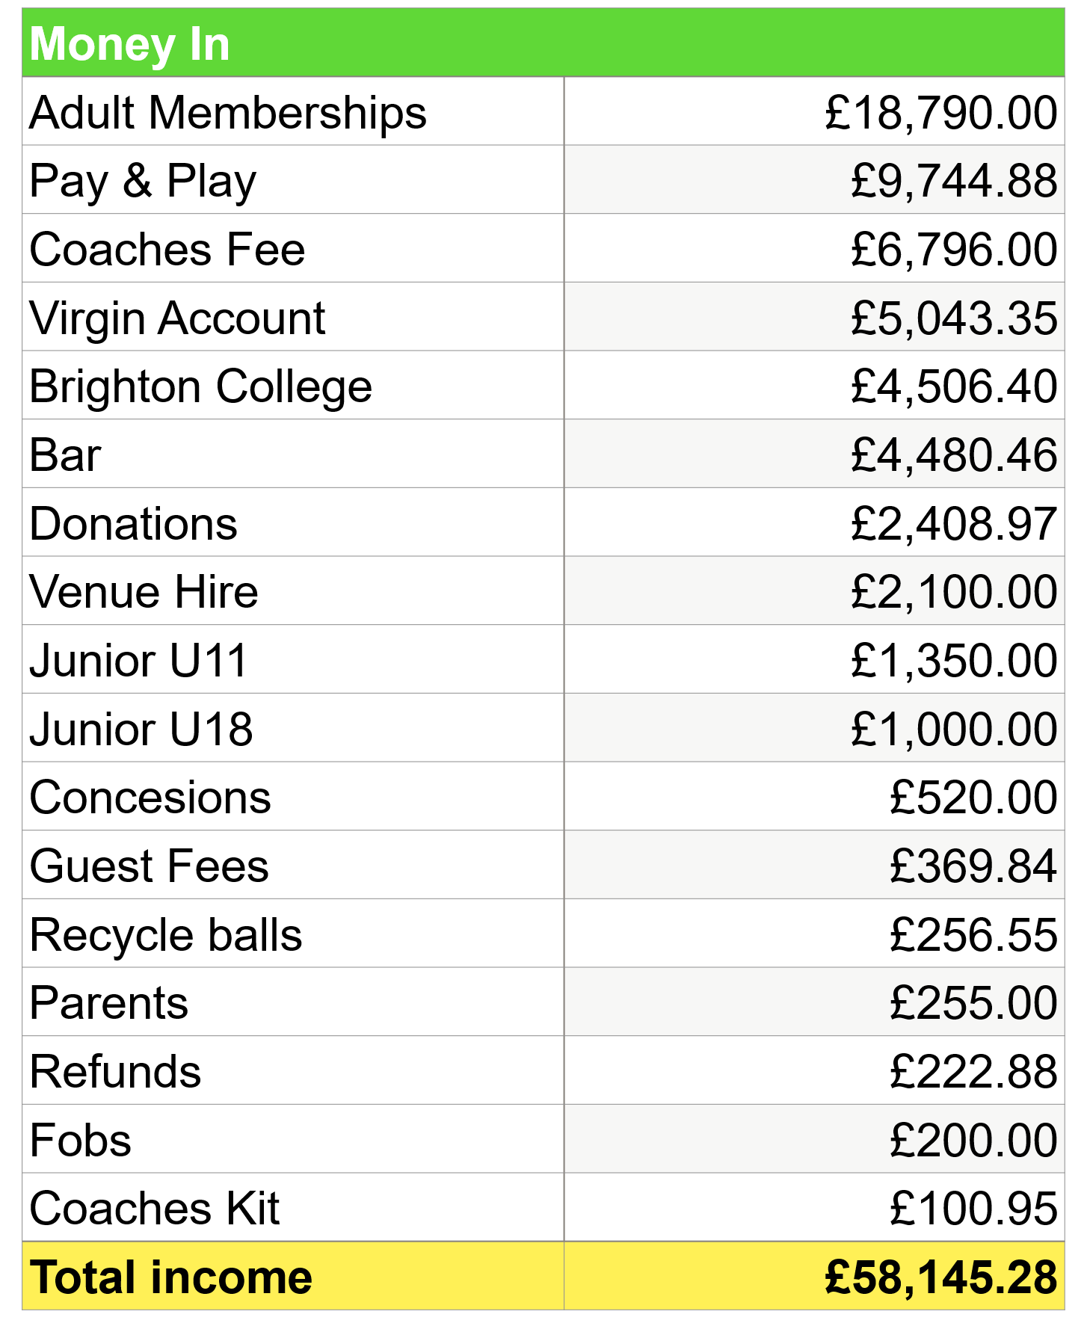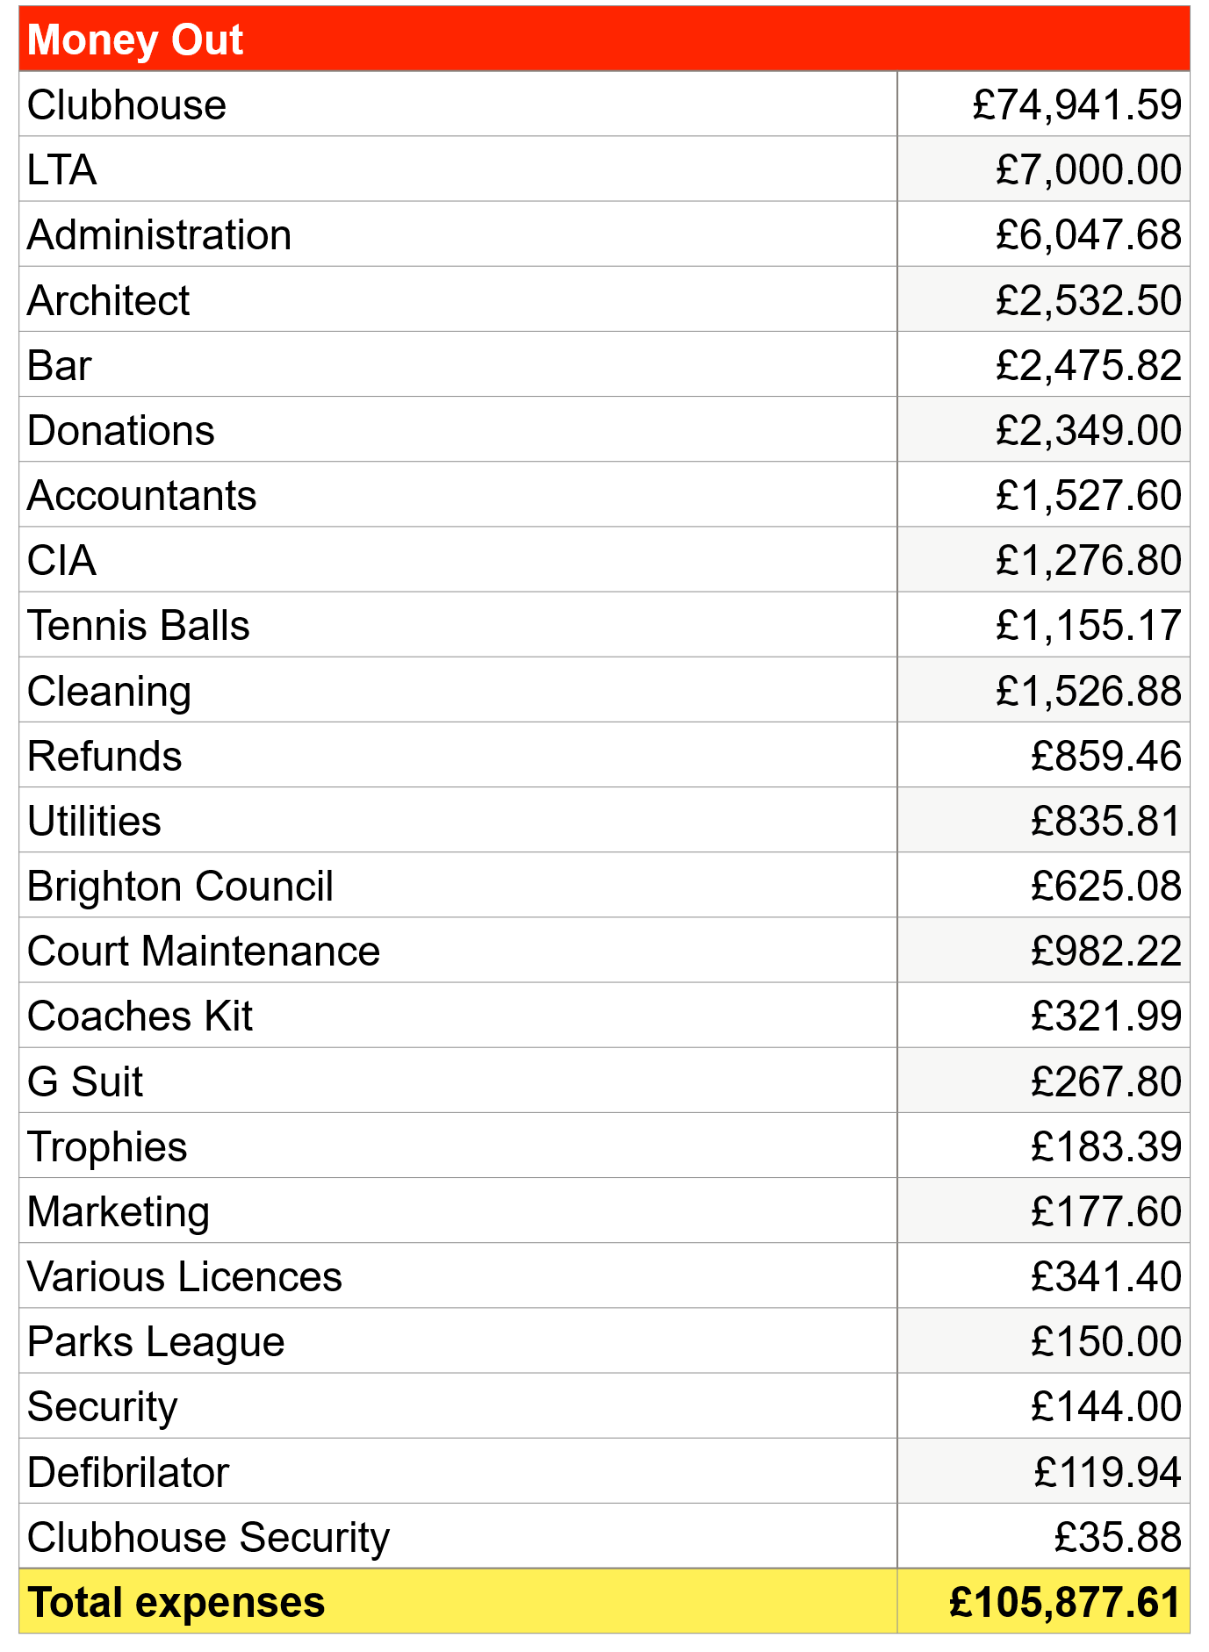
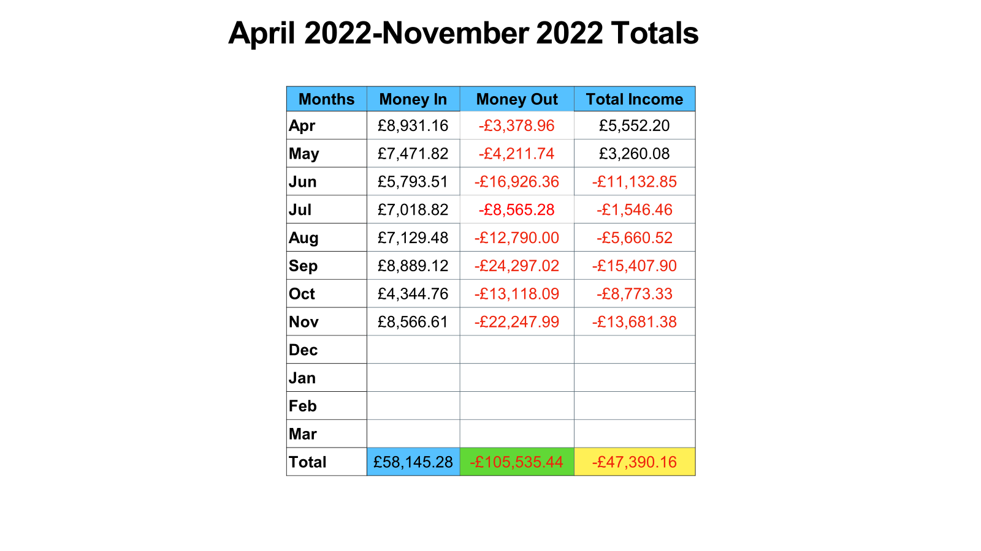
Questions
Question from the floor - The loan, have we paid any of it off?
Alan Sanchez – Yes we have paid £7k so far. It’s a 10 year, interest free loan.

Question from the floor – Bar total profit?
Alan Sanchez – As can be seen from the most recent figures available, current bar profits to November 2022 are running at £2.004.64.

Comment from Wendy Powell - The 1st & 2nd teams when played Preston Park they drank a lot. This provides good income to the club!
Comment from Alan Sanchez – a lot of players from other clubs say they would join here because of our clubhouse.

Question from Barbara – Coaches kit cost?
Alan Sanchez – The coaches have to purchase them from Queens Park Tennis Club.

Question from the floor – Who is the CIA?
Mel Bowden – The CIA make the gates and the computers that operate the floodlights through ClubSpark.

Question from Barbara – What is the annual deficit? How long will it take to pay off the loan?
Alan Sanchez – We have £63k paying off debt to LTA. We are paying that off over 10 years, we had sufficient assets to cover payments needed in the period. With a turnover of £80k, we have a net £10-£15 profit.

Question from Rhys Daniels – What is the strategy for the future?
Stephen Lee –To date the focus of the board has been firmly on trying to get the current range of building works and court upgrades finished. The Board recognise that as this is achieved we will need to produce a revised 3-4 year strategy plan and we will be doing that in the next few months to post on website and have an meeting to discuss as it becomes available.

ADOPTION OF THE 2021/22 ANNUAL ACCOUNTS
The accounts for 2021/22 were formally adopted by the meeting.

APPOINTMENT OF THE INDEPENDENT EXAMINER (Accountants) FOR 2023
It was agreed to appoint Messrs. Chisnall Corner Ismail & Co. as the Independent Examiner of the QPTC accounts for the period 2022/23.

2023 MEMBERSHIP PACKAGE (Conrad Brunner)
Conrad Brunner outlined the projected membership package for 2023/24. This is set out below.

Membership 2023 - Full Adult Membership Package from April 1st 2023
Personal court usage
Two court hours per day bookable 7 days in advance (14 hours a week)

Box Leagues
Winter Ladder Singles - at present organised by Terry
Summer Ladder Mixed - at present organised by Farehk

Club Sessions Summer
Sunday 2.00pm – 5.00pm (4 courts)
Monday 6.00pm – 8.00pm (4 courts)
Friday 6.00pm – 8.00pm (4 courts)

Club Sessions Winter
Sunday 2.00pm – 4.00pm (4 courts)
Monday 1.00pm – 3.00pm (2 courts)
Friday 1.00pm – 3.00pm (2 courts)

Members Tournaments throughout the year 13 (Thirteen) – Plus Parks Finals (No8)

 | Tournament | Date | Organiser
1 | New Year Day | Sunday 1st January 1pm | Pauline
2 | American | Saturday 4th February 1pm | Pauline
3 | Seniors | Saturday 4th March 1pm | Pauline
4 | Wooden Racquets | Saturday 8th April 2pm | Pauline
5 | Charity | Sunday 7th May 2pm | Pauline
6 | International | Saturday 20th May 2pm | Pauline
7 | Serve and Volley | Saturday 24th June 2pm | Pauline
8 | Parks Finals | Saturday 22nd July 1pm | Parks
9 | Chris Anderson | Saturday 12th August 2pm | Pauline
10 | Club Finals | Saturday 2nd September 1pm | Charlie *
11 | Mixed Division 1/2 | Saturday 30th September 1pm | Sam
12 | Ladies | Saturday 7th October 1pm | Brenda
13 | Mens | Saturday 14th October 1pm | Sam
14 | Mixed Division 3/4 | Saturday 24th October 1pm | Sam
As before a small charge of £2.00 per player will be made by the organiser towards food, tennis balls, prizes and engraving (if applicable) Queens Park Tournaments only. *Club provide balls

Membership 2023 - Membership Tariffs  Adult Membership £125.00  Students £70.00  Junior U11 £35.00  Junior U18 £45.00  Parent/Guardian £. 5.00  Social £. 5.00 | Park League Season subs - 2023  £25.00 for the season (18 matches)  Or  £2.00 for Home and Away matches

Discussion
Parks League subs explanation:
This is, the board believes, a modest, fair and proportionate charge for Parks League matches, and represents excellent value for all participants.
Conrad also pointed out that to his knowledge all other Parks League clubs charge a sub in one form or another. King Alfred's £2 home and away every match, no exceptions. Saltdean and St Anns, the same etc.
QPTC players paid subs for every match up to 2017. This charge was deferred in 2022, which cost QPTC most of £2,000.
It's not fair that the rest of the club/membership should subsidise an excellent benefit for team members. Parks League matches absorb a huge amount of prime tennis time, 6-8pm, Tuesday, Wednesday and Thursday, April to August every summer.
A final point is that those Queens members who play for Saltdean in the Sussex County League pay a match sub of £5 per match. There is no justification for paying a sub to Saltdean, but not to Queens!
Comment from Wendy – We have never paid subs. Barbara agreed with Wendy on this point.
It is clear from this interchange that this point is disputed.
Comment from Sam – I have spoken to the captains, and they don’t pay subs.
Question from Katy – What does the £25 cover?
Conrad Brunner – We need to pay £25 per team for registration with the league. We also need to cover the cost of fresh balls for every home match.
Comment from the floor – the balls we used for matches, are they used for club sessions? I don’t think they are. They should be so that other club members are not playing with flat balls. That is part of the membership fee which is going up each year.
Response: Yes the balls are used for club sessions.
Question from Wendy - What does a can of balls cost?
Conrad Brunner - £5.50-£6.00
Comment from the floor –don’t want to create diversion with Parks League and non-Park League. Some get more bang for their buck than others. Don’t want them and us.
Question from the floor - At a discussion many AGMs ago, what was decided as our membership was a lot higher than other clubs, because that it included the subs element for the Parks League. Under the projected membership increase for 2023/24 membership will go from £110 to £125 so now excludes subs. That is a big jump.
Stephen Lee – We can have a discussion with the tennis committee re the £2 subs.
Question from the floor – We appear to offer no concessions - as a community interest company should we not do so? So low incomes can’t join this club at a concessionary rate.
Comment from Conrad – We do in fact offer a range of concessions on individual request and for registered students. Over all the board believe that the current and proposed membership fee is both affordable and offers good value for money to the membership.
Question from Barbara – Successful clubs are winning the leagues. All the people that play in the leagues and organise the leagues – if we took out expertise else where the club would be in a bad state. We get people in because our teams are good.
Comment from the floor - Some people want to join because they are local and want to play tennis. Not because the club is doing well in the leagues.
Comment from Stephen Lee – The 13.5% increase in the membership fee in part will help us to pay back the £70k loan to the LTA, to rebuild the sink fund to cover additional future investment in court management and to provide us with some comfort through what we believe will be a very volatile time in the next 12 months (energy costs etc).
Re concessions: in the past this has included students and younger people. We have not had published concessions to date based upon social economic status. The Directors agreed to review the current policy on concessionary rates.
Comment from the floor – it should be shown as ‘student’ since it’s on concession.
Comment from Rhys Daniels– it’s a good value membership, but I would support concession memberships.
Comment from Wendy - we need a set of minutes from the tennis committee.
Questions from Barbara - can you tell us when the clubhouse is available, so we can plan events?
Response from Alan: The online calendar system that is accessible to everybody clearly shows when the clubhouse is available for booking and when it is booked. Additionally, should any member wish to have further information they can liaise directly with me.

ANY OTHER BUSINESS

Questions Submitted in Advance

Wendy Powell: Can we have access to the table tennis table. Then we can play table tennis if you come to play tennis and it’s raining? Only 15 people have a key (only x3 women). Can we have keyholders improved access?
Stephen Lee – we will look into this again, but providing wide ranging pavilion access to all members is both problematic in terms of protecting the valuable assets held in the pavilion, delivering security to the dangerous levels of power held in the Mains room and in ensuring compliance in relation to the standing of our current insurance cover.

Wendy Powell: What do coaches currently pay to the club? What are the coaching arrangements currently in place for Saturdays and Sundays?
Coaches are charged £5 per hour.
Can coaches book for Sunday? Yes, they can but in practice this only occurs for one coach. Saturday Arrangements? The contention here was that Courts are booked out by the coaches on the Saturday mornings but on occasion the courts are not used. Please therefore can the coaches cancel the court if it’s not to be used. This was noted by the coach’s present.

Brenda Maguire: Can you email a reminder of the AGM to all members?
Conrad Brunner – yes this was emailed out ahead of this meeting.

Brenda Maguire: Can the Directors send out a copy of the annual accounts and the figures 24 hours before the meeting.
Conrad Brunner –Yes, this was done and the figures are available to all members in the members area on the website.

Brenda Maguire: Can coaches not book private lessons after 13:00 on Saturdays please?
Mel: I tend not to work after 13.00 on Saturdays as tournaments start in the winter at 13.00. However, Mel made the point that he could not speak for Jimmy who had by this time left the meeting.

Kevin Boyd: I am concerned re aggressive behaviour on the courts, is there a code of etiquette?
Stephen Lee responded – Stephen indicated that this is a good point and that the Directors would investigate further.
[Footnote for Clarification: Subsequent investigation reveals the presence of a member code of conduct that is published on the QPTC website. The Directors have subsequently agreed to review this and other policy documents over the coming three months] .

Ian Teasdale: Can we reinstate access to the courts for drop in for Friday?
Stephen Lee – The courts are already available, there is no need to reinstate this availability. The club has always made courts available for member drop in on Friday afternoons in the winter period and Friday evenings in the summer period.

Sally – Re the accessible toilet, it surprised me to learn access was only on purchase of £10 fob. Is this because of insurance? Maybe deposit of £10? Doesn’t keep in keeping in with inclusivity of the club.
Stephen Lee –You raise a good point and we will review this provision.
Comment from Barbara Michael – there should be a woman on the board on the directors.
Conrad – the current board have actively sought to develop the diversity within the board over the past 12 months and we shall continue to do so moving forward. The gender point is well made.

ADJOURNMENT OF MEETING
There being no further business to discuss the meeting adjourned at 19:22.

