
QUEENS PARK TENNIS CLUB, BRIGHTON
ANNUAL GENERAL MEETING

Sunday 7th November, 17:30 – 19:35
Clubhouse, Queen’s Park Tennis Club
ATTENDANCE
BOARD | MEMBERS x16
Charlie Baines (Chairman) | Jo Davies (minutes) | Terry Nevin
Mel Bowden | Prof. Stephen Lee | Jerome Hansen
Conrad Brunner | Farehk Jahangir | Janet
Stephen Davies | Barbara Michael | Chris Rendal
Alan Sanchez | Jimmy Smith | Trisha Rendal
 | Kevin Boyd | Simon Mills
 | Charlie Brown | Sam Waller
 | Gabrielle Healy | Katie Johnson

APPROVAL OF THE CHAIRMAN
Mel Bowden requested approval from those present for Charlie Baines to chair the meeting. All in favour. CARRIED.

APOLOGIES
There were apologies from:
Eddie Crowder
Brenda Maguire
Pauline O’Reilly
Sally Roscornnes
Ian Teasdale
REPORTS FROM THE DIRECTORS
MEL BOWDEN
Director - negotiating the lease and legal aspects
Coach - Adults
Project Manager - overseeing all maintenance, repairs and capital projects
including quotations for future works liaising with all on site contractors

The Lease
Nearly five years ago the head of City Parks met us and confirmed the Council could no longer support the 10 tennis sites around the city. This was in line with football and cricket pitches which already were self-managed. Pointing to the bowling green he warned us that’s what will happen if we don’t act. “To do nothing is no longer an option” was his quote. Given the City had 12 bowling greens and now has 6 we took the advice seriously.

Queens Park formed a CIC and put forward a bid to self-manage the site and after 8 months the full Council voted to accept the bid.

The problem with the original lease was it was a very old and modified document used for many Councils owned properties and had numerous clauses which we had to challenge. Examples being we had to maintain shared public ways, shared underground services and lighting or one paragraph banned us from providing food. Alcohol was banned in one section and permitted in another. Use of the area between the Clubhouse and the courts was not agreed unless we requested it.

By now the Council solicitor dealing with us had changed three times which added to delays. It took over three years to remove all clauses.

You have to understand we were not dealing with a single person representing the Council but four departments City Parks, Estates, Properties and Legal which is not easy.

One section that appeared was a break clause at 5 years into our lease. This meant we could be asked to vacate without reason. It has taken 8 months to have this clause removed.

Contained within the lease was a maintenance clause stating we paint, renew or maintain all parts of the Clubhouse and courts on a 1-to-3-year basis. We could not accept responsibility for this until all parties agree on the handover condition given our lease was 25 years. The Club identified many areas that needed maintenance and negotiated over £125K of works before we could accept the handover condition. The final stage of those works, the external areas of the clubhouse, should be completed next week.

When all outside works are complete, we will instal the defibrillator. The unit is jointly funded by the Club and Friends of Queens Park*
Jerome is our liaison between the Friends and the Club
*The unit has now been ordered

I should add the Contractors repairing and decorating the Clubhouse have offered to donate £500 to a charity of our choice. We suggested Amaze the local charity who support families of children with special needs. The Club already offers a Saturday coaching session for this group.

With the appointment of a single Council representative six months ago progress has been improved and we appointed a new solicitor in order to establish a formal communication channel between Club and Council. It’s worth noting, we are now dealing with Council solicitor number four. Last remaining conditions have just been agreed which include public right of ways and pay and play charges.

The Council still refuse permission to prune the overhanging Sycamore tree on Court 1. This court was completely resurfaced three years ago and since then the Club has paid over £4,500.00 to continually repair the damage under the tree. Such is the damage Court one now needs to be PARTLY resurfaced at a cost of £12,740 +VAT. (The problem will be the join between old and new).

We continue to ask for the Council to visit the site in order we can address some problems they have refused our requests. Strange that Connick Tree Care who are tree surgeons, have spent two weeks pruning and pollarding over 40 trees in the park yet we are excluded.

Ward Councillor Nick Childs has agreed to visit us in order to see for himself our concerns.

Floodlights
We took the opportunity to instal the floodlighting columns during lockdown to avoid disruption when we re-opened. I should say all under court ducting had been previously installed by us when the courts were resurfaced. It took 10 months to gain planning permission as it required to go to Council Committee. To light all four courts, we require a new power supply from East Drive and a side extension. This has been agreed in our new lease. After six months negotiating the LTA have offered an interest free loan to fund some works. All planning permissions have been granted and with the signing of the lease we are able to draw down funds.

We cannot complete the floodlighting installation ahead of drawing down the funds as this would breach our loan agreement.

Please be aware that on our permission is this important caveat:
The applicant should be aware that whilst the requisite planning permission may be granted, this does not preclude the department from carrying out an investigation under the provisions of the Environmental Protection Act 1990, should any complaints be received.

I’m sure you will all understand what that implies. However, that said, we are able to temporary wire two courts as a ‘test’ without jeopardising the loan.

The lighting contractors have agreed to vary our contract in order to achieve this and have put temporary control equipment in. We have completed the upgrades to the booking system which allows members and non-members to book either court 1 or 2. Final testing of the lights and commissioning will take place asap.

Additional comments (Mel Bowden)
The floodlights were tested on Thursday (4th Nov). This has raised one complaint from a local resident.
Comment from Janet – From the road there is less tree cover than say, Preston Park.
The floodlights will increase court hours (year-round) by 35%.
There will be a cut off of 10pm for the floodlights to be turned off (to be inline with the bylaw). We plan to have a 9pm cut-off, however there could be occasional extensions until 10pm for tournaments etc.
The lights automatically come on (5 mins prior to booking) if pre-booked and auto turn off. If not booked in advance there is an 8 min delay for booking to go through the system.
Q: Julian – What is the cost to use the lights? What if you cancel?
A: Mel - £6 per court for members. For non-member £14. Currently only courts 1 and 2 have the lights available. Payment will still be due if you cancel within 24 hours. If there is a genuine reason to cancel the booking within the 24 hour window, for example unexpected rain or injury, then a credit will be given so a future booking will be made free of charge.

Q: Terry – Can there please be an update/announcement on the website to the members so they are aware of what is happening with the lights?
A: Conrad – Yes, we are drafting an announcement to send in the next few days.
UPDATE: Member’s email sent re floodlights on Thursday 11th November 2021.

Club Progress
It may be worth reflecting how far the Club has come in four years but still a lot of development to be undertaken.
We have planned new fencing and electronic gates for courts 5 and 6 which the LTA have agreed to part fund. We have, after two years of requesting, just been given permission to run power from the clocktower to the gates.
It is important we protect these courts as last month the net was set on fire and melted into the court. The cost of a new net was £135 but the repair of the court is estimated at £500.
We intend to install CCTV to cover these courts
Finally, a second new side extension to the Clubhouse will include an accessible toilet, again planning permission has been granted for this. I know this is very important and we intend to build up funds to commence construction as soon as possible
To date the Council have spent just over £125k*. The Club just over £116k.
*NB since the AGM a further £26K has been allocated by the Council to repair the rear of the Clubhouse which has asbestos lining.

Lastly, next planned works which will include the completion of the floodlighting, three phase power, side extensions, new toilets, courts 5 and 6 fencing and gates
- Completion of floodlights £45k
- Three phase power £12.5K
- East extension including new plant room £32k
- Court 5 and 6 fencing £25k
- Power from clocktower £4.5k
- West extension including new accessible toilet £29k.
Total £148K

The final phase of the clubhouse improvements, not included above, includes new toilets, commercial kitchen and bar. This phase is estimated in the order of £80k.
Can I at this point thank Stephen Davies who advises me on Health and Safety, building practices and discusses all quotations we receive for works on site. It’s important for me to have someone in the trade to refer too.

CLUB SECRETARY REPORT (ALAN)

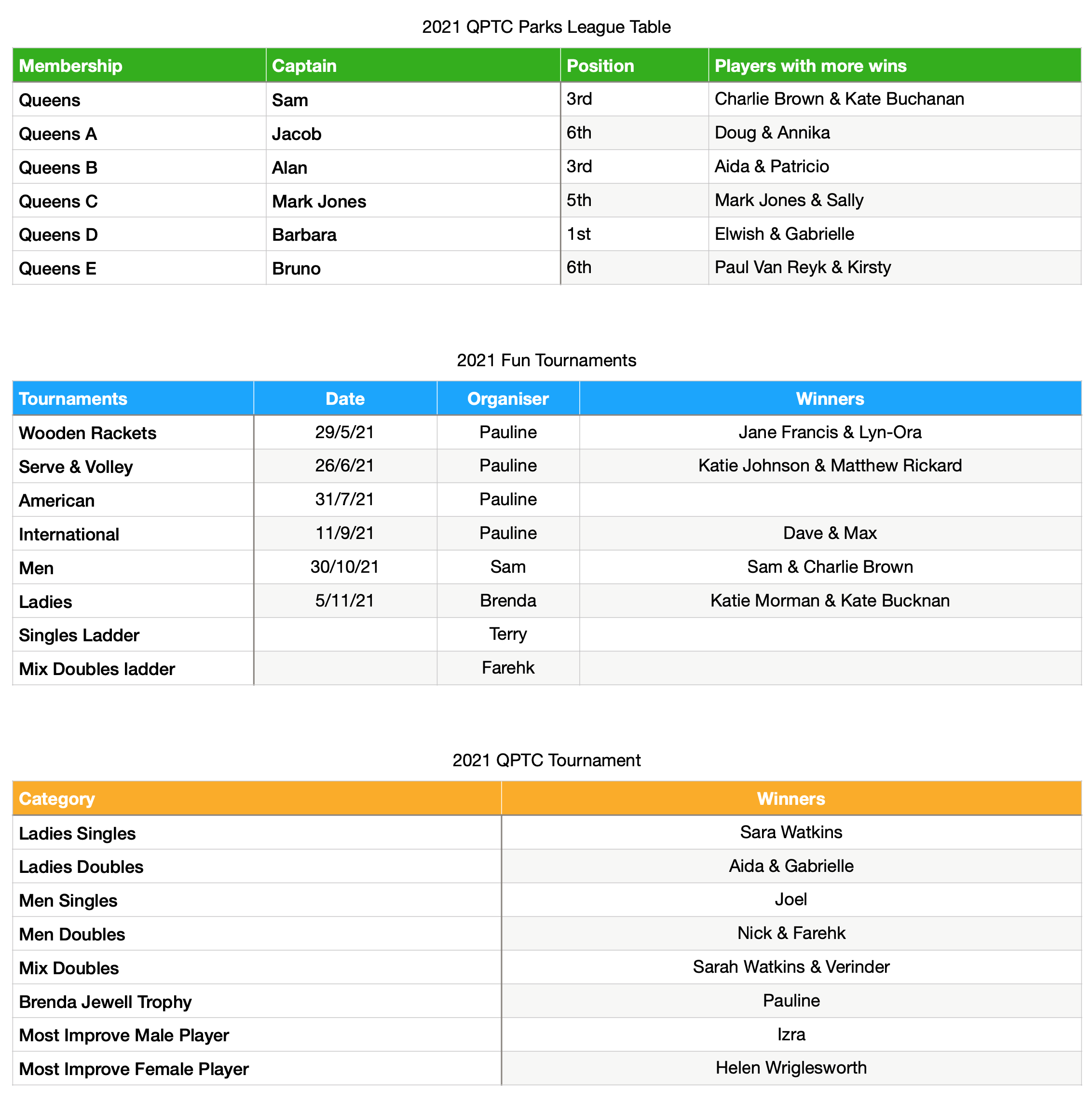
2022 Parks League Season:
The captains will be: Sam (Queens & Queens A)
Alan (Queens B & Queens C)
Barbara (Queens D & Queens E)
The 2021 Parks League AGM was held on 17th November. The minutes of that meeting will be published shortly.
Thank you to Pauline for organising fun tournaments.
Thank you to Terry and Farehk for organising the Singles and the Mix ladders.
Thank you to Charlie Brown for organising the QPTC Tournament.
Question from Charlie Brown – Who is on the Park Committee?
Answer: Conrad – Mic Cox, Jon Lightbody, Mandy Taylor, Conrad Brunner and Mike Jenner.

MEDIA REPORT
QPTC Media report (delivered by Conrad)
QPTC does work hard to maintain a strong online presence. We don’t have the
money to advertise, but we can invest time and effort into a good website, and that
can make a real difference. This year we spent £1,300 upgraded the QPTC website to
optimise it for mobile, to boost its’ SEO online performance, and improved the overall
design. We now have a dedicated online area for members, which includes a live
CCTV feed. This is excellent quality and worth checking out. It also allows us to post
member’s details for competitions, which we would not normally like to do in a public
webpage.

We have effectively two websites. QPTC and our booking page at ClubSpark. Both
are updated regularly. Both, interestingly, are on the first page of google search, so
even our booking page has a higher profile than nearly any club in the city.

On Google, Queens Park Tennis Club has more positive online reviews than all of
the big clubs in Brighton combined: Badgers, Dyke and Preston LTC. Pay & Av, the
biggest club in the city, home of Tennis Sussex, has 38 positive online reviews.
Queens Park Tennis Club has 47.

We run a Google Business page which can generate over 100,000 references
a month from Google. This online activity is transferred into real visits, phone calls
and lots of hits and clicks on the website. All this activity is enhanced by regular web
postings across twitter, Facebook and Instagram.

Instagram has clearly emerged as THE preferred social media for tennis players. All
the top stars and tennis organisations now focus on Instagram over Facebook and
Twitter. We set up our Queens Park Tennis Club Instagram account two years ago,
and it’s regularly updated by myself and Jimmy Smith. It’s doing very well. Some
context: (Instagram followers)

Dyke Park Tennis - 154
Brighton Beach Tennis - 222
Pay & Av - 272
Southdown - 290
Weald Tennis - 320
Badgers - 342
Queens Park Tennis Club - 548 followers
All of this helps keep the ship buoyant. Bigger demand for coaching, bigger demand
for holiday camps, bigger demand for pay and play, bigger demand for venue hire,
bigger demand for membership. It’s something that sets us out not just from other
parks clubs, but from other private clubs too. [Nominate QPTC as community club
of the year.]

BAR/EVENT
REPORT: Venue Hire (delivered by Alan)
The restoration of the clubhouse was an important part of our self-funding model,
and venue hire was able to make a decent contribution towards club funds.

Obviously, QPTC then took a hammering from Covid-19 pandemic. All club events
suspended, and regular weekly groups like Pilates were cancelled. No quiz night, no
Open Mic events, so leading to thousands of pounds of lost revenue.

Things are now beginning to pick up with a Venue hire of £650 just last month;
- QPTC Labour Party 2hrs monthly
- Friends of QP
- Film crew, 2 days £500
- Birthdays
- Adult birthday party

BAR PRICES: (Conrad) Our prices are what we need to make it worthwhile, so when someone buys a drink, they know they are making a contribution to the welfare of the club.
Prices are still cheaper than pub prices. It’s a job of work keeping the bar operating
and stocked, and we put a small but worthwhile price on that.
If we can do a deal on, say a barrel of beer, and be confident of selling it all.

Additional comments (Alan)
We pay a licence to operate the bar so please can we ask members not to bring their own drinks.

MEMBERSHIP & COURT BOOKING (Alan)
COURT BOOKING – There have been complaints from members at being unable to book a court. However, during the two weeks showed on the table below you can see that on average only 56% of courts were booked.

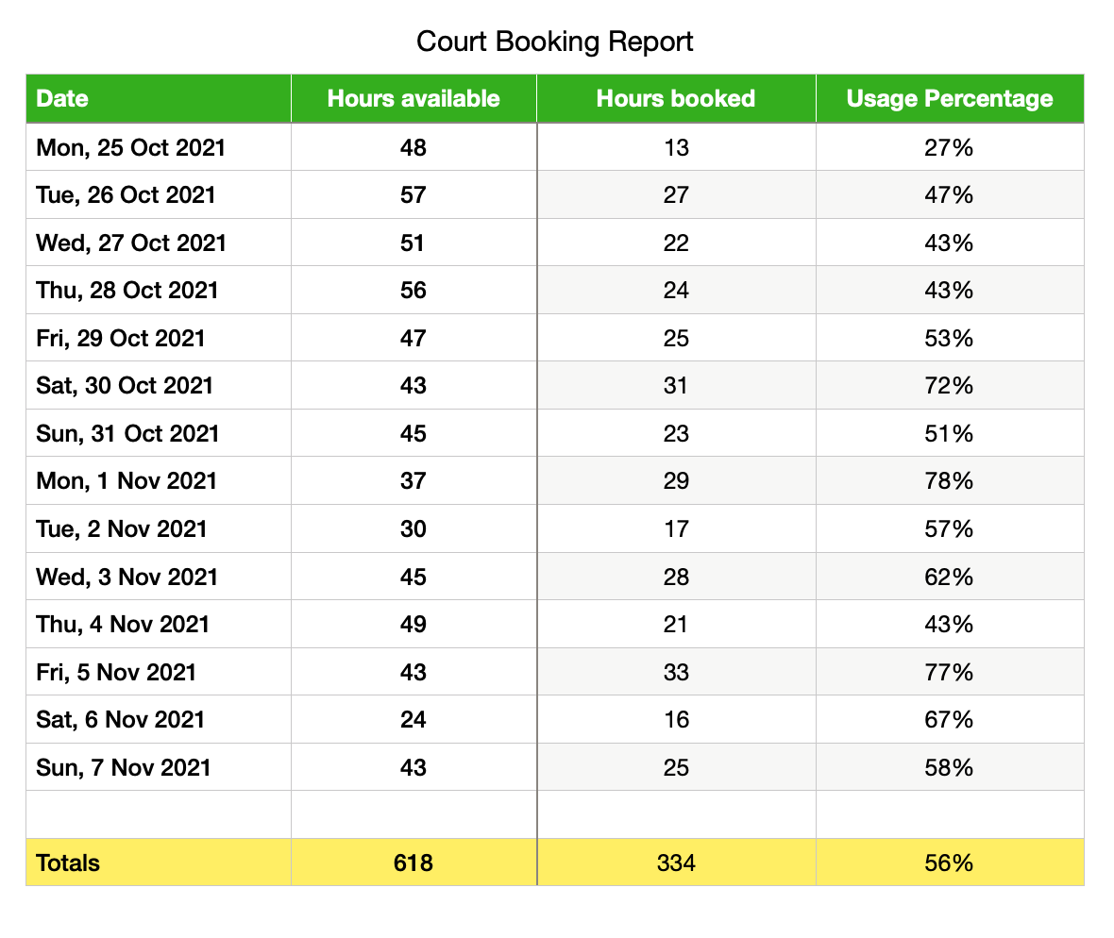

The biggest complaints have been around weekend court bookings from coaches. We’ve negotiated a contract with our coaches whereby their fee has been increased by 100% and their weekly hours capped to 40.
Coaches do use the courts at the weekend, however, the financial contribution made by our coaches together with Brighton College bookings has allow us to keep membership’s fee unchanged for the last 2 years.
As an example, on Sat Nov 6th we had the lady’s tournament. During that day there were 24 hours of court time available, yet only 16 hours were booked. It is quite clear that there are courts available every day of the week including weekends. Members wishing to book a court at a particular time on a regular basis have the opportunity to do so seven days plus three hours in advance.
Our fun tournaments are often played on Saturday afternoon as the upper courts are often not booked.
From April to November between Club Sessions and Parks League matches members were able to play 58 hours per week plus 21 hours with their own bookings. Against a £100 per year fee, that’s less than 10p per hour. Compare that with the fee paid by Pay and Play members (£8.69 per hour)
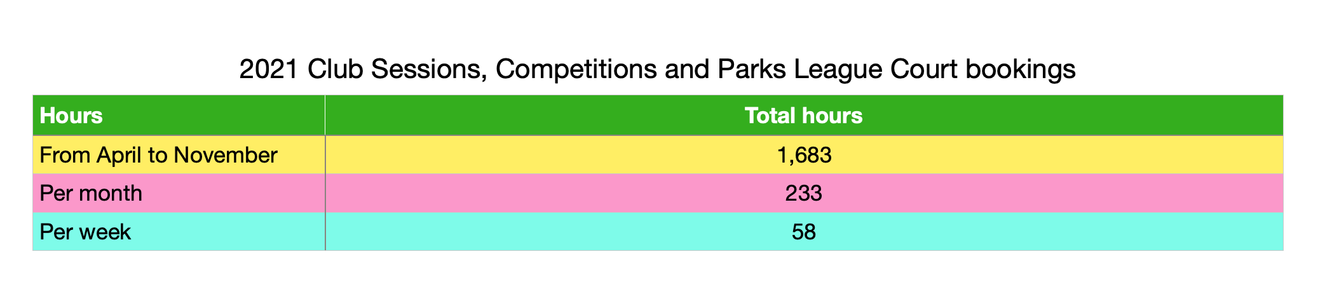
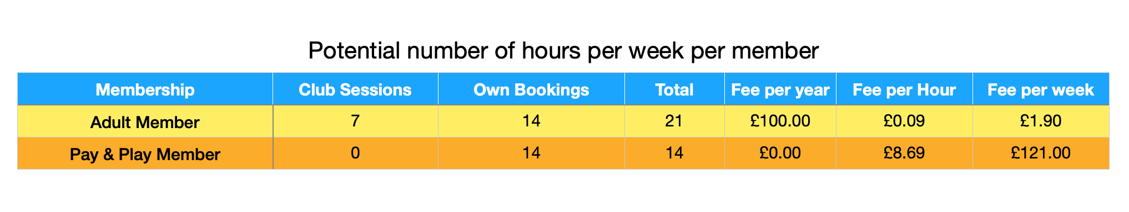

MEMBERSHIP Report (Alan)
The table below shows the number of members, both full members and members of the public that uses our facilities. It also shows that at the moment there are 70 people on our waiting list. As the Club Treasurer, those 70 people represent a revenue of £7,000 but as a Membership Secretary I am aware that the enrolment of those 70 individuals would mean an enormous increase in court bookings. That’s why the decision to have a waiting list was taken as we felt that it is more important to have a surplus of booking hours available than to increase our revenue.
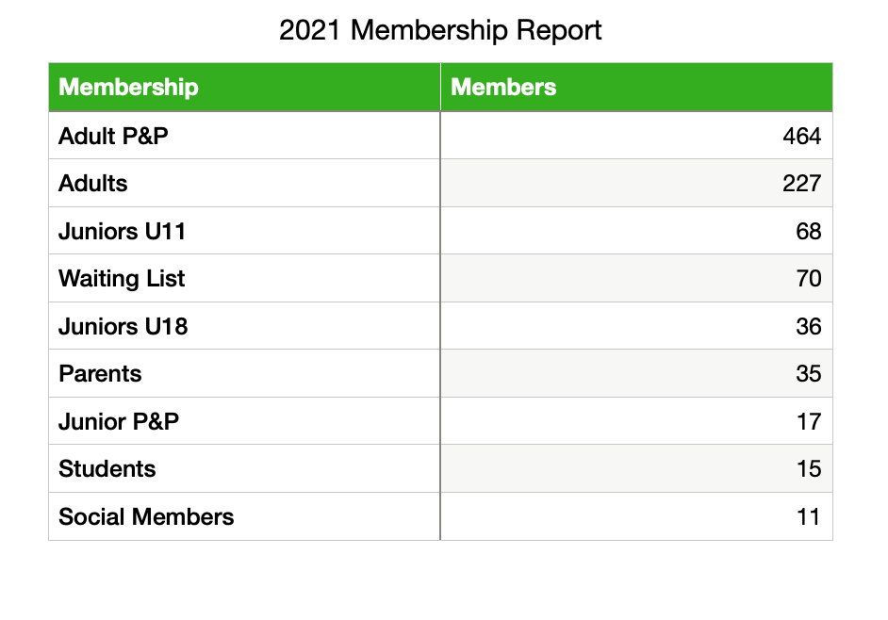
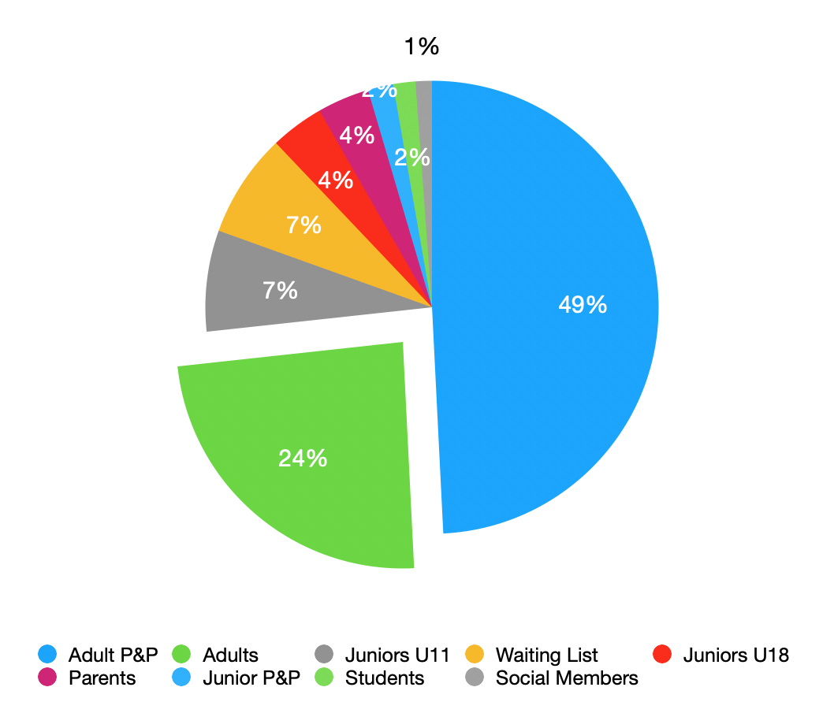
MEMBERSHIP FEE PROPOSAL (Alan)
We would like to propose an increase to the membership fees by approx. 10%
Adults £110
Students: £60
Junior U18: £40
Juniors U11: £30
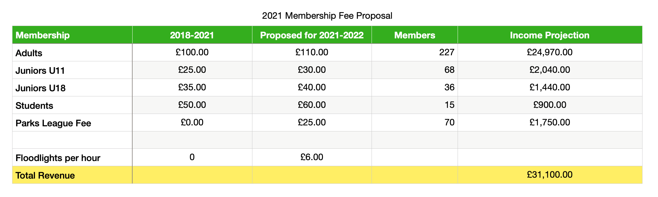
Mel Bowden requested approval from those present for the membership to increase by 10% per annum. All in favour. CARRIED.
A Parks League Fee of £25.00 per person was also proposed. The cost will include a branded t-shirt with a QPTC logo.
The reasons for this fee:
- We spend more than £1000 on tennis balls.
- Parks League fee per team (£25.00). We’re represented by 6 teams so £150.
Once members pay the fee and are registered there is no guarantee that they will play matches but if they play less than 5 matches the fee will be refunded.
Other clubs such as Saltdean and Hove charge a nominal amount on the day of the match (£2-£3 per match), but both clubs confirmed that the system is not satisfactory as it is difficult to implement.
Q: CHARLIE Brown – Is there currently a tennis committee? Do we want one? Directors make one decision, and the committee could make others.
A: ALAN – There used to be a tennis committee 2 years ago and as Club Secretary I lead that committee but we found that it was more efficient for different members of the committee to take charge of particular jobs. For example, Bruno is in charge of the recycle balls, Pauline is in charge of organising fun tournaments, Terry continued to organise the singles ladder, Charlie Baines was in charge of the weeding, Gaby was in charge of the catering, etc. I encourage other members to become part of the committee by volunteering to do certain jobs such as being in charge of the trophies, a job that requires to collect the trophies from last year’s winners, take them to be engraved, collect them once engraved and distribute them to the new winners, but due to lack of response I ended up doing it myself. Weeding and other repair and grounds work are now carried out by Mel and myself.

A: MEL – The Directors make the infrastructure. Directors have responsibility for the loan and legal aspects and once the lease is in place the LTA will have to be aware and approve of any changes to Directors.
MEL – After conferring with the Directors regarding Charlie Browns suggestion I can confirm that the Directors agree for a committee to be formed and maybe Charlie Brown would like to form it.
The Directors decided on reflection to remove the park league fee until the tennis committee convene.
It was agreed by the meeting to withdraw the resolution and separately create a committee. Charlie Brown to draw up the framework for a committee. Need to agree on a framework. Is there a set number.

COACHING
REPORT: COACHING [MEL BOWDEN] (delivered by Conrad)
After lockdown was lifted on March 29th the Club saw a huge uptake in both private and group participation. The coaching sessions are now delivered by Mel, Jimmy and Ben. Across the week there are four drop-in groups covering Improver Intermediate and Advanced levels. Beginners have a seven-week course which is repeated throughout the year.

BLAGSS transferred their summer coaching from Preston to us and following a very successful course, requested a permanent group session during the winter. We were unable to offer them a regular slot because of court availability.

The very popular Saturday Improver group for non-members was repeated in the summer but again we were unable to offer winter sessions because of court availability.

It could be we can offer both these groups coaching when the floodlights are operational.

We are pleased that many new faces are joining in the Club sessions and participating in the tournaments organised by the club.

Overall, the last 7 months 90 new adult players have been introduced to the Club of which 26 have joined and a further 19 are on the waiting list which stands at 70.

Additional comments (Mel Bowden)
Terry and Charlie have been organising great tournaments which have included new members. Many thanks to Terry and Charlie
Good feedback from new members attending the club nights. Reported to be a friendly welcome from those hosting.
REPORT: JUNIORS TENNIS [JIMMY SMITH] (delivered by Jimmy)
Update on the current junior coaching programme at Queens Park.
In 2021 which we’ve expanded the afterschool programme with classes running on
Mondays, Wednesdays, Thursdays, Fridays, Saturdays and Sundays. We had around
30-40 children attending the junior pizza night throughout the summer, with around
120 children in the coaching programme. This is a free programme for junior
members.

The children have enjoyed playing in our new box leagues and the junior closed
tournament had its’ largest turnout this year with 30 players competing on the day.
The Amazeballs disability tennis junior session continues to attract regular 4-5
players on the weekly basis, we’d like to try and promote for some new players to
join. This programme is now in its 4th year. The holiday camps this year have been a
fantastic success with over 200 players joining up.

LTA Youth Start courses were popular this summer where we introduced 100 new
players to the club via the programme. This is the LTA’s flagship tennis initiative, all
over their branding at Eastbourne and other LTA events. Their ambassador is Emma
Raducanu, who has always been enormously appreciative of the LTA and has gifted
her 2021 US Open trophy to the LTA’s National Tennis Centre in Roehampton. LTA
Youth is a very big deal indeed, and Queens Park Tennis Club runs more LTA Youth
courses than all the rest of the clubs in Brighton put together.

QPTC has been “Invited by the LTA to manage a new tennis outreach programme at
The Crew Club in Whitehawk. The LTA have accessed some funding and are
looking to put on some regular free, weekly tennis coaching sessions for the young
people in Whitehawk who would never usually have the opportunity to access tennis.
They have two multi-use courts at the venue as well as an indoor hall.”

Q: Jerome Where is the saturation point with regard to Junior members?
A: Jimmy We are not taking on new members. We have 132 junior members, more than other City Clubs.
Q: Jerome Parks League tournament for Juniors (under 9s)? Had happened in Preston Park before.
A: Jimmy The Preston Park operation is not sanctioned. We don’t have the player base but I’m happy to try and organise something. LTA run them, but to quite high standard.

FINANCIAL REPORT (Alan)
The two financial reports are self-explanatory. The first report indicates our Income and expenditure for the 2019-2020 financial year. The second report indicates our income and expenditure from April 2020 to October 2021.
Due to the lockdown, resurfacing of the courts and floodlights installation we experienced a £,148 deficit. This deficit has already been recovered during the course of this year.
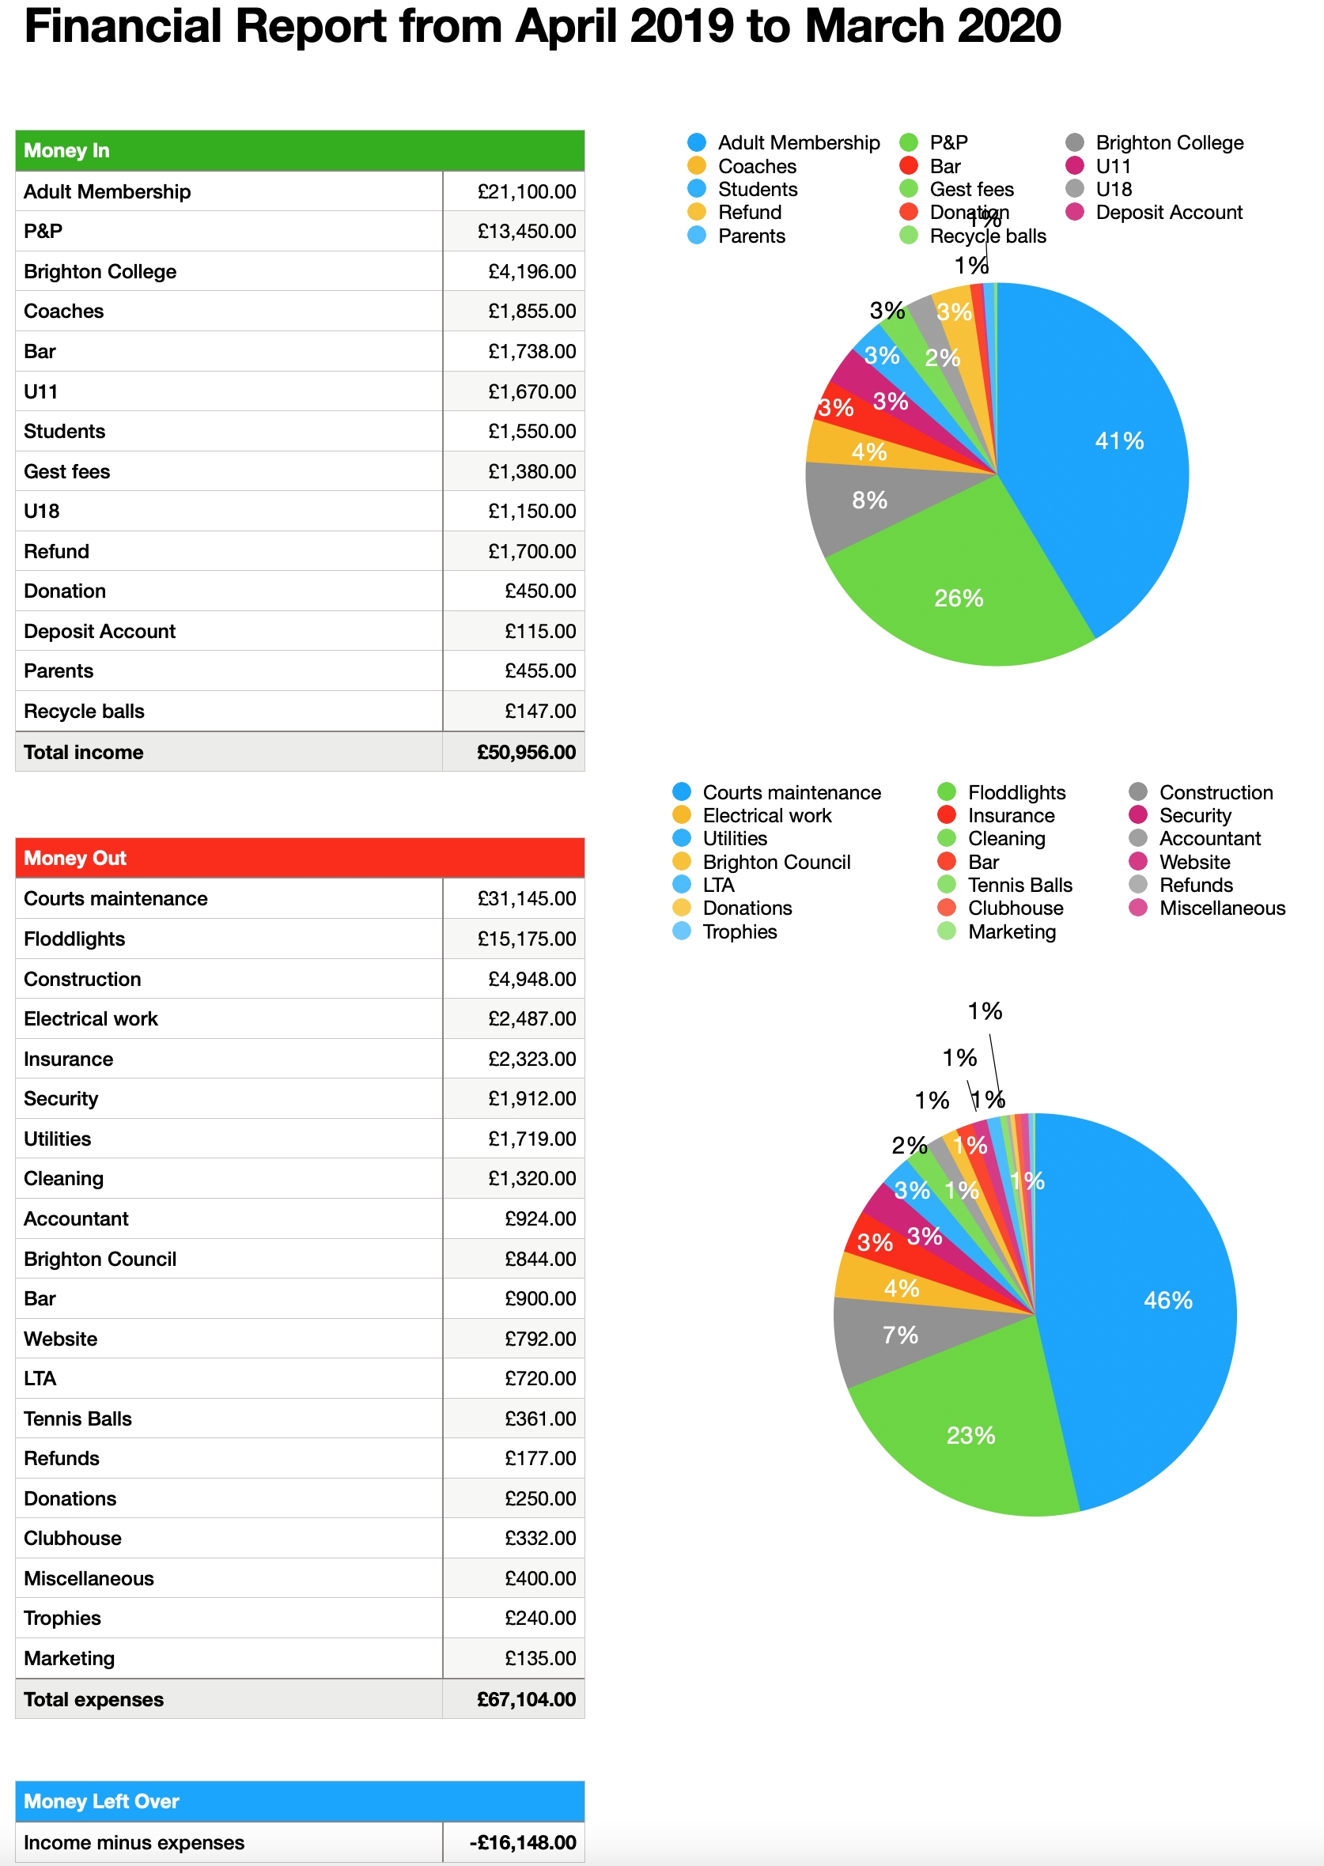

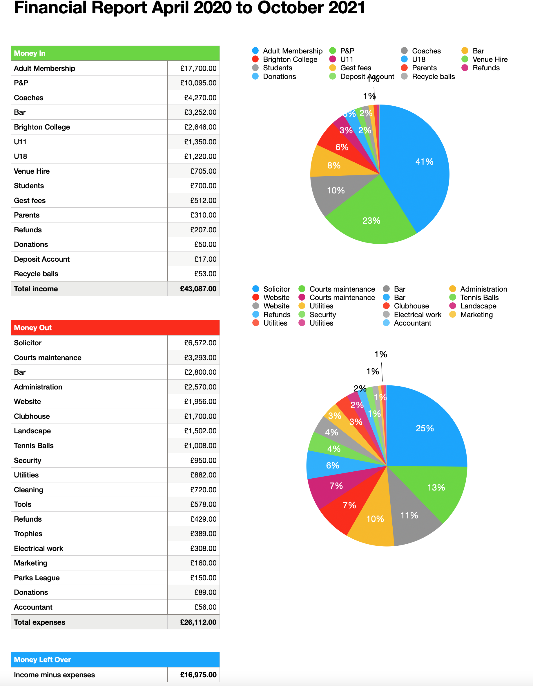


QUESTIONS SUBMITTED IN ADVANCE
Q: Kevin - The new floodlights are proving ideal resting place for pigeons and seagulls, and they are leaving their droppings at the base of the poles holding them. Then our tennis balls are landing in them, this is very unhygienic, and seagulls carry a lot of salmonella too. Would it be possible to have those stainless-steel Bird spikes or one of those fake Owls placed on top to keep the birds away?
A: Mel – if floodlights need to be adjusted we can do this with scaffolding tower to save costs.
Q: Jerome: Does the club have any intention to further broaden access to courts for non-members? The rate for non-members’ court booking strikes me as very prohibitive. Other local clubs (e.g., Dyke Park) are offering non-members off-peak prices for court bookings (£5/hour between 7 am-3 pm) and even an off-peak season ticket (£50) which allows free court usage at certain periods. Could such a tiered pricing system be implemented at the club?
A: Alan – The club receive a large financial contribution from pay and play. This is the reason for courts 5 and 6 being made available to pay and play members during club sessions.
The pay and play amount are set by the council. £8.69 per court which is very reasonable.
A: Mel – we can’t vary the court costs to the public as it’s in our lease, there is an impact on court availability to members
Q: Sally Rosscornes: Is there or will there be a racquet buy/sell noticeboard on the website or the clubhouse?
A: Mel: Our Web designer is working on that and Alan is looking at setting up a wWhatsApp group
Q: Brenda: It seems difficult to get a court at the weekend for friendly game or ladder games. It would be helpful if the coaches could individually coach during the week and maybe allow members to use courts 1,2,3,4 at weekends because a large number do work from Monday to Friday?!
A: Alan: The answer was given on the Court Booking report.
Q: Brenda - Who now has keys for the clubhouse? Bearing in mind, the lack of toilet facilities for women, should there not be more women with keys? Who now has keys and why?
A: Mel – the key fobs have a log entry. The insurance doesn’t allow more than 15 fobs. When the lease is signed this will change and will be down to us. Keyholders will need to be clearly told of the responsibility.
A: Alan –The Clubhouse key and fobs are held by those who need access to the clubhouse:
Coaches: Mel, Jimmy and Ben.
Directors: Conrad and Alan.
Club Session hosts: Sam, Pauline, Bruno and Barbara.
Cleaner.
Emergency call out: Mark Jones and Eddie.
Contractors when working on site.
Brighton College.
Possible Venue Hire clients.
A key and fob were offered to Wendy if she agreed to host two club sessions a month. Wendy declined.
If a key and fob were to be given to a specific lady for the sole purpose of using the toilet, other ladies would be asking for a key too. Not forgetting that men have the same toilet need as ladies.
Q: Brenda - Why have the directors that have left not been replaced? Should this not be a matter for all club members to consider?
A: Prof. Stephen Lee - There is no requirement to replace directors. Board of directors themselves decides to have more directors and appoint new directors as needed (if directors leave for example). There is no requirement to consult members.
QUESTIONS DURING THE MEETING
Q: Charlie Brown– What is the responsibility of the CIC and the Directors?
A: Prof. Stephen Lee – The club has been established in law as a Community Interest Company (CIC). Within a CIC the assets of the club are both owned and protected by the community that comprises the membership of the club – in this case the members of the tennis club. The initial members of the club will have identified and elected the Directors of the CIC and therefore the Directors of the Tennis Club. The rules governing the operation of the CIC are set out in the Memorandum & Articles of Association (M&A) of the club. Currently the M&A provide that the Directors of the CIC are singularly and collectively solely responsible for the day to day running of the club, save that the members can call them to account at a general meeting of the club where they can demonstrate that the Directors are not acting in the best interests or purpose(s) of the club.
The Directors are required to make fiduciary report to Companies House on an annual basis but they are not now required to hold an annual general meeting each year (Companies Act 2006) although it remains normal for one to be held on a regular basis. Given the impact of Covid on the ability of many community groups to meet in person over the past two years, it is perhaps not surprising that an AGM has not been held for three years.
Whilst the Directors retain full responsibility in law for their actions, they must be able to demonstrate that all of their activities are undertaken in the best interests of the members of the CIC in pursuance of its purposes. Members can bring a resolution (under the M&A) designed either to hold the Directors to account over particular actions/decisions undertaken by them or to amend the range and the scope of their duties and/or responsibilities. To do so legitimately such a resolution would need to be drafted and circulated to the membership through the request for a general meeting of the CIC at which the special resolution would be debated and resolved by a vote of the members entitled to vote at the meeting. Currently the M&A provide that it is the current Directors of the CIC that have the power to appoint new Directors to the CIC.
Conrad – We were required from the council to create a CIC (other local clubs have done the same). The assets belong to the community. We can’t sell the QPTC and build flats etc. It protects the club and the members.
Prior to the CIC being formed 12 people registered interest after initial meeting the numbers reduced to eight with Pauline and Charlie Baines not wanting to be directors. The remaining six became directors.
We are about to sign a lease for 25 year and £70,000 loan with the financial responsibility on director’s shoulders.
Q: JANET - Why no female Director? We should encourage a woman to become a director!
A: Conrad – Stephen’s wife was Director. However, she stepped down due to workload. Mark Cull resigned but remains – welfare officer. Keith Stollery stepped down and this role was taken up by Alan along with membership role after Pauline resigned the role.
A: Alan: At present we don’t recognise the need to appoint a new director, male or female as there is no specific job that could be allocated to the new director. The running of the club requires for directors to take on active roles and not just attend meetings and give an opinion.
Q: Chris Rendal – Is financial reporting required? Can directors share the reports?
A: PROF. STEPHEN LEE – The Directors of the CIC are required to provide two regulatory reports on an annual basis. The first is the return that they must make to The Office of the Regulator of Community Interest Companies (CIC Regulator)'s – the C34 annual report. The second comprises the annual report and accounts of the CIC which are lodged at Companies House where the CIC is registered as a company. The specific content of the accounts to be filed vary with the size of the organisation. For organisations with a turnover of not more than £10.2m, a balance sheet total of not more than £5.1m and an average number of employees not more than 50, the organisation can supply abridged or simplified accounts.
ADJOURNMENT OF MEETING
There being no further business to discuss the meeting adjourn at 7:34pm.

